THE MOULTON ADVENTURE GROUP
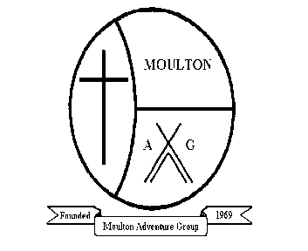
Registered Charity No. 510-065
The Moulton Adventure Group
The Crompton Building, School Lane
Moulton, Northwich
Cheshire CW9 8PD
www.moultonadventuregroup.org
Dear Parents/Guardians,

If your young person requires a new uniform please fill out the order from below. Please hand the form and money (in cash) into a member of staff and then they will pass it onto myself and I shall place the order. However, we must have a minimum of 4 orders to be able to have them embroided with the Moulton Adventure Group Logo. If we do not have 4 orders we will keep your request for uniform and put it with the next batch of orders we receive.

If you have any further questions please don’t hesitate to ask a member of staff.

Thank you

Harriet Hart
Group Leader
Moulton Adventure Group
………………………………………………………………………………………………………………………………
Name of Young Person:
Product | Cost | Size | Quantity
Polo Shirt (Kids) | £10.50
Sweatshirt (Kids) | £17.50
Hoodie (Kids) | £16.80
Polo Shirt (Adults) | £14.00
Sweatshirt (Adults) | £18.70
Hoodie (Adults) | £19.00

Total Cost …………………………...

Contact Details:
Name: | Signature: | Date:

Note: It is important that this form is completed thoroughly and that information disclosed is up to date

FORMS TO BE RETURNED TO THE GROUP LEADER

